 ROI

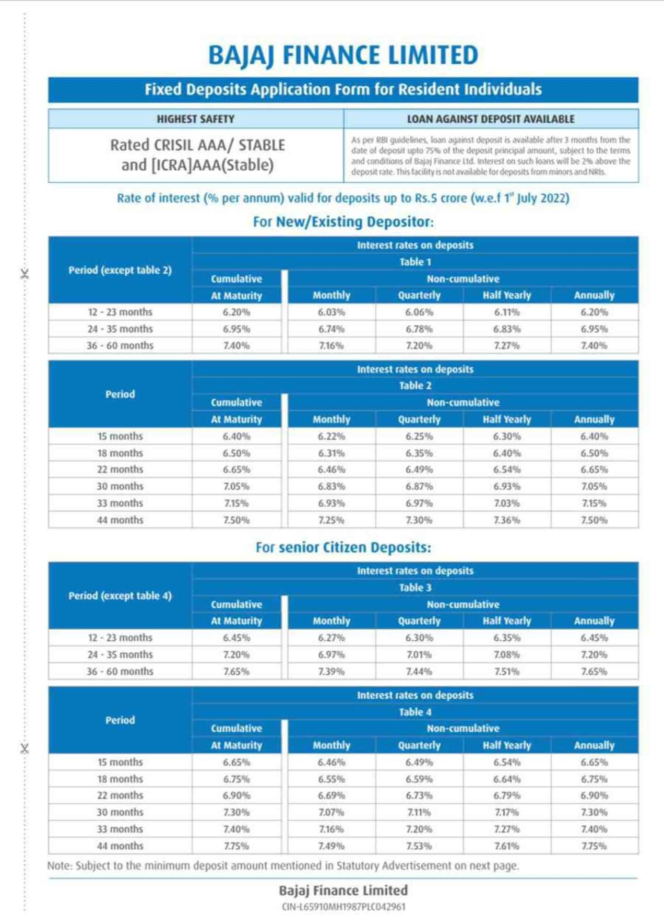

PROCESS NOTE



Going ahead FD application form can submit at the below mentioned addresses also .The same is opened as part of convenience to deposit fresh and renewal applications. Apart from FD applications, all service requests would be undertaken in the below branches. Customers can also visit the branches to resolve their service queries. Below mentioned are the list of branches for your perusal –

|  |  |  |  |
| --- | --- | --- | --- |
| **Branch Name** | **Brand Name** | **City** | **Complete Address** |
| ChurchGate | Bajaj Finserv | Mumbai | Apartment no.1, Gr. Floor, Moti Mahal, C.T.S no. 1631, Road 195, J Tata Road, Fort, Churchgate, Mumbai, 400020 |
| Dadar | Bajaj Finserv | Mumbai | Shop no. 4, Gr floor, Bhavani complex A, Priyadarshini Mahila CHSL, Bhavani Shankar Road, Dadar West, Mumbai, Maharashtra 400028 |
| Andheri | Bajaj Finserv | Mumbai | SHOP NO 3 GROUND FLOOR HUBTOWN SUNMIST SAI WADI N S PHADKE ROAD NEAR EAST WEST FLYOVER ANDHERI EAST MUMBAI 400069 |
| Jaya nagar | Bajaj Finserv | Bangalore | Lakshmi Mansion,81/b,22nd cross,8th main road, opposite to Kotak Mahindra bank,Jayanagar,3rd bolck,Bangalore-560085 |
| Lajpat Nagar | Bajaj Finserv | New Delhi | Plot no L - 95, Ground floor, Lajpat nagar-II, New Delhi 110 024 |
| Malleshwaram | Bajaj Finserv | Bangalore | Office no. 58/4, 1st Floor, Old no  533, New Municipal no. 58/4, 8th Main Between 17th A Cross & 18th Cross, Malleshwaram, Bengaluru, Karnataka 560055 |
| JM Road (Deccan) | Bajaj Finserv | Pune | Survey No. 364, Shop No. 3, Ground floor, Jangali Maharaj Road, Shivaji Nagar, Pune, Maharashtra 411005 |

Please note –

* The branches would be working on all days of the week except Sunday and Public holidays
* The Timing to accept the fresh application form would be 9:30 to 17:00 Hrs.
* Timing for service request is till 17:00 hrs on all days.
* All discrepancies regarding the application/service request form would be informed by the operations manager in the branch.